# Supplementary Tables

|  |  |  |  |  |
| --- | --- | --- | --- | --- |
| Research Study | Used TE Material | wt% of TE Material | Approximate Load in Failure (N) | Approximate Deflection in Failure (mm) |
| Wang *et al [32]* | Bi0.5Sb1.5Te3 | 87.5 | 2 | 0.50 |
| 83.1 | 2.25 | 0.60 |
| 78.9 | 3.65 | 1.80 |
| 66.3 | 4.25 | 2.80 |
| 53.1 | 4.80 | 6.00 |
| 35.8 | 4.60 | 10.00 |
| This research | Bi2Te3 | 80.0 | 1.95 | 0.34 |

# Supplementary Table 1: Comparison of flexural properties of the thermoelectric filaments used in Wang et al[32] and this research.

# Supplementary Figures

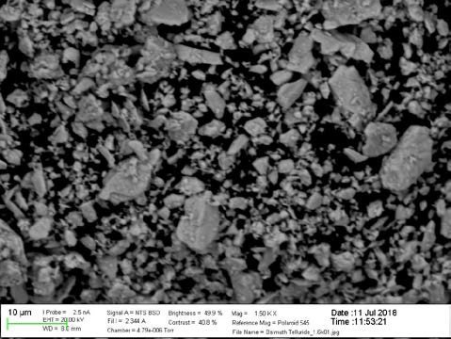

**Supplementary Figure 1:** SEM Images of the bismuth telluride thermoelectric powder

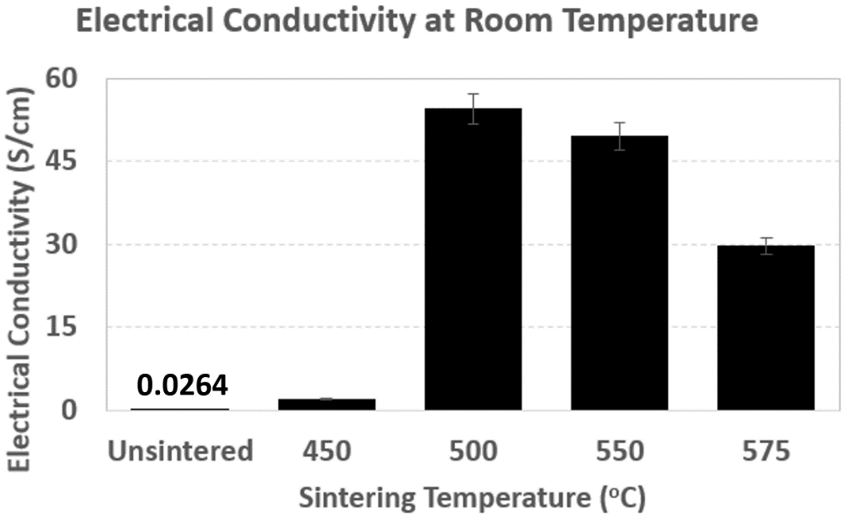

**Supplementary Figure 2:** Electrical conductivity of thermoelectric specimens under room temperature and effect of sintering thereon: As-printed and sintered samples under temperatures from top to bottom: 450, 500, 550 and 575 oC.

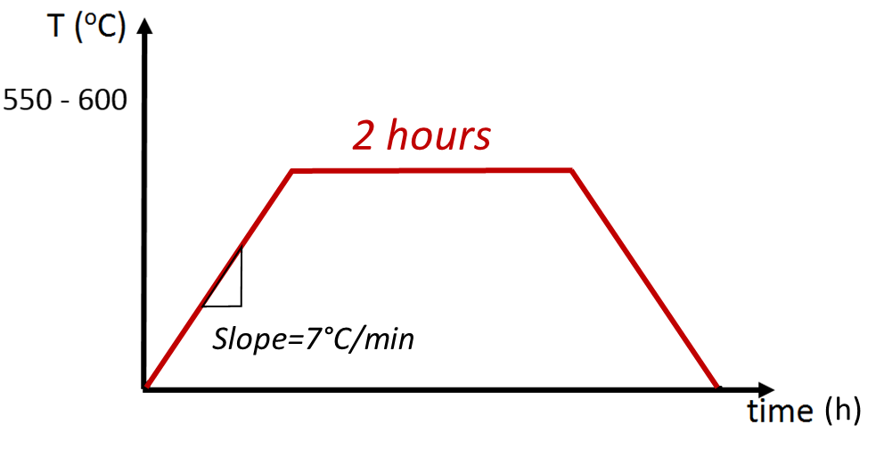

**Supplementary Figure 3:** Three-segment thermal sintering process of 3D printed thermoelectric materials. Heating and cooling rates were set to 7°C /min to protect alumina tube against thermal shocks. Sintering temperature duration was 2 hours for all samples and sintering temperature was varied between 400°C - 550°C.

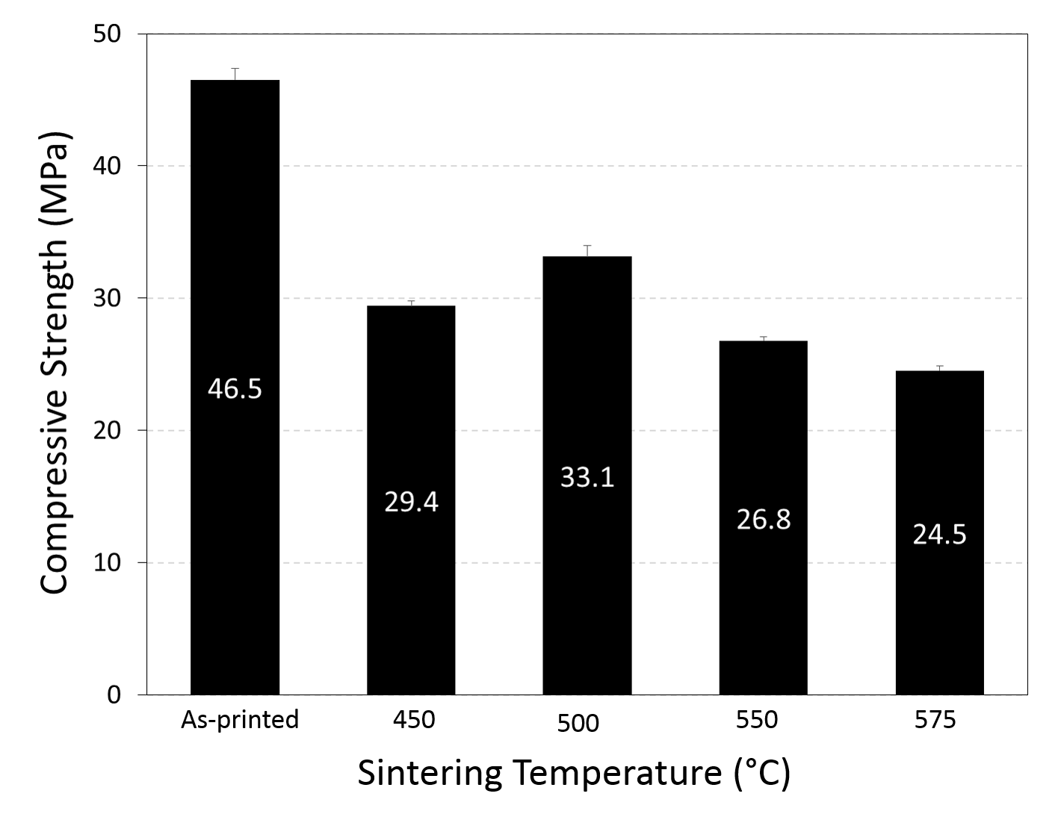

**Supplementary Figure 4:** Compression test results for as-printed and sintered specimens as a function of sintering temperatures in accordance with ASTM C1424.

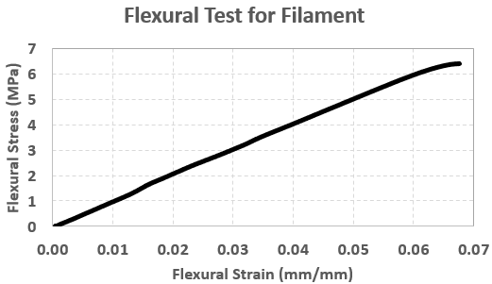

**Supplementary Figure 5:** Flexural strength of as-extruded thermoelectric filament, performed in accordance with ASTM D790.

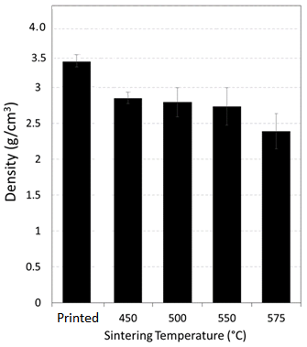

**Supplementary Figure 6:** Density of thermoelectric specimens: as-printed and sintered under temperatures from top to bottom: 450, 500, 550 and 575 oC.

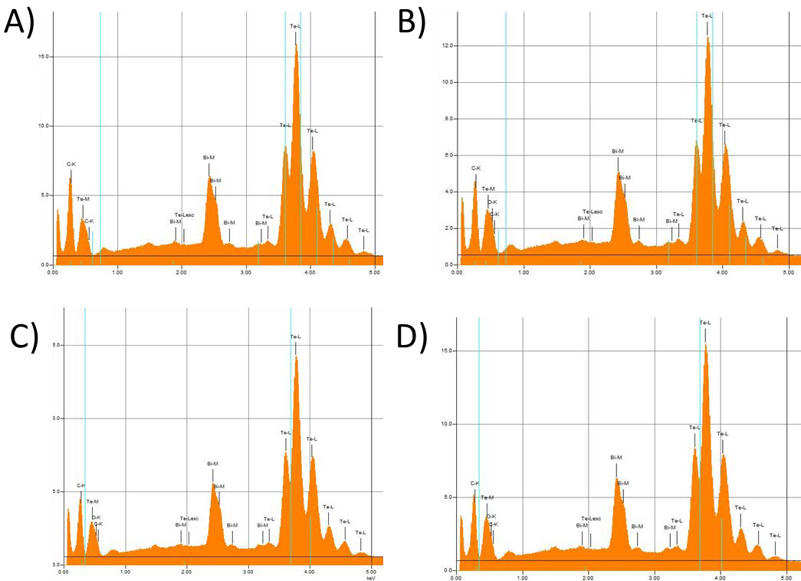

**Supplementary Figure 7:** EDX analysis for sintered thermoelectric specimens sintered at A) 450, B) 500, C)550 and D)575 oC.

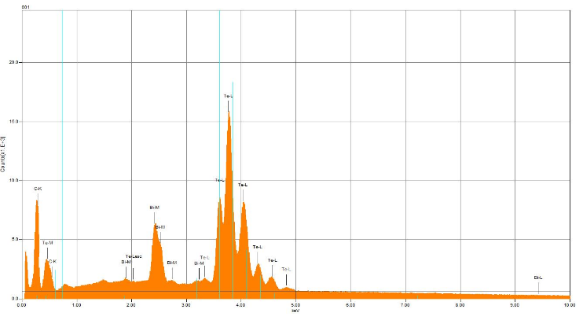

**Supplementary Figure 8:** EDX analysis for as-extruded thermoelectric filament

# List of Main Figures

**Figure 1**: Schematic representation of fabrication of sintered samples

**Figure 2**: SEM micrographs of sintered thermoelectric samples sintered at A) 450 oC (Retaining ABS particles are shown with the arrows), B) 500 oC; C) 550 oC D) 575 oC.

**Figure 3**: SEM-EDX Elemental analysis results as a function of sintering temperature: A) Carbon Mass fraction, B) Oxygen Mass fraction, C) Bismuth Mass fraction, D) Tellurium Mass fraction.

**Figure 4**: Temperature dependence of thermoelectric properties of specimens sintered at four different temperatures: A) Seebeck Coefficient, B) Electrical Conductivity C) Thermal Conductivity, D) Dimensionless Figure of Merit

**Figure 5:** Pictures of the 3D printed thermoelectric specimens prior to sintering A) Concentric cylinders photographed in two views, B) 5-point star shaped thermoelectric specimen

# List of Supplementary Figures

**Supplementary Figure 1:** SEM Images of the bismuth telluride thermoelectric powder

**Supplementary Figure 2:** Electrical conductivity of thermoelectric specimens under room temperature and effect of sintering thereon: As-printed and sintered samples under temperatures from top to bottom: 450, 500, 550 and 575 oC.

**Supplementary Figure 3:** Three-segment thermal sintering process of 3D printed thermoelectric materials. Heating and cooling rates were set to 7°C /min to protect alumina tube against thermal shocks. Sintering temperature duration was 2 hours for all samples and sintering temperature was varied between 400°C - 550°C.

**Supplementary Figure 4:** Compressive strength of as-printed and sintered thermoelectric specimens, with sintering temperatures from top to bottom, performed in accordance with ASTM C1424: 450, 500, 550 and 575 oC.

**Supplementary Figure 5:** Flexural strength of as-extruded thermoelectric filament, performed in accordance with ASTM D790.

**Supplementary Figure 6:** Density of thermoelectric specimens: As-printed and sintered under temperatures from top to bottom: 450, 500, 550 and 575 oC.

**Supplementary Figure 7:** EDX analysis for sintered thermoelectric specimens sintered at A) 450, B) 500, C)550 and D)575 oC.

**Supplementary Figure 8:** EDX analysis for as-extruded thermoelectric filament.

# List of Supplementary Tables

# Supplementary Table 1: Comparison of flexural properties of the thermoelectric filaments used in Wang et al[32] and this research.